4.1.1 SET OPERATIONS
ALGORITHM
Step 1: Start
Step 2: Read elements of Set A
Step 3: Read elements of Set B
Step 4: Compute Union of A and B
Step 5: Compute Intersection of A and B
Step 6: Compute Difference (A − B)
Step 7: Display Union, Intersection, and Difference
Step 8: Stop
FLOWCHART
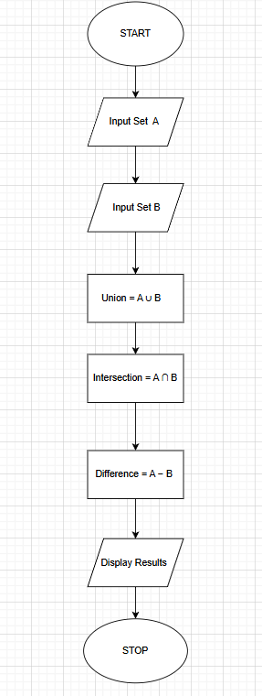
PYTHON CODE :
set_a = set(map(int, input("Set A: ").split()))
set_b = set(map(int, input("Set B: ").split()))
union_set = set_a | set_b
intersection_set = set_a & set_b
difference_set = set_a - set_b

print("Union:", union_set)
print("Intersection:", intersection_set)
print("Difference:", difference_set)
PROGRAM
